Diabetes Prediction System
Mohammed Junaid
Department of Computing Technologies
SRM Institute of Science and Technology Kattankulathur, 603203 Ms3253@srmist.edu.in

Dr. G. Usha
Department of Computing Technologies
Faculty of Engineering and Technology
SRM Institute of Science and Technology
Kattankulathur, 603203 ushag@srmist.edu.in
Dr. C. Pretty Diana Cyril
Department of Computing Technologies
Faculty of Engineering and Technology
SRM Institute of Science and Technology
Kattankulathur, 603203 prettydc@srmist.edu.in
Ravada Karan
Department of Computing Technologies
SRM Institute of Science and Technology Kattankulathur, 603203
Rs5641@srmist.edu.in

Abstract— This article presents a robust machine learning-based system for the early prediction of diabetes, aiming to enhance preventive healthcare and support timely medical intervention. The proposed model leverages advanced machine learning algorithms to analyze key health indicators, including glucose levels, blood pressure, BMI, age, insulin levels, and other relevant clinical features. By utilizing supervised learning techniques and training on large, well-labeled medical datasets, the system achieves high prediction accuracy, enabling efficient risk assessment for individuals. The approach includes data preprocessing, feature selection, and model optimization using algorithms such as Logistic Regression, Random Forest, Support Vector Machine (SVM), and Gradient Boosting. Extensive evaluation through performance metrics such as accuracy, precision, recall, and F1-score demonstrates the model’s reliability and effectiveness. Additionally, the system offers a user-friendly web interface that allows users to input health parameters and receive instant feedback on their diabetes risk level. This predictive tool can assist healthcare professionals and individuals in making informed decisions, promoting early diagnosis, reducing complications, and supporting proactive lifestyle changes. Ultimately, this work contributes to the growing application of artificial intelligence in the medical field, offering a scalable and accessible solution for diabetes prediction and health monitoring.
Keywords— Diabetes Prediction, Machine Learning, Healthcare AI, Logistic Regression, Random Forest, SVM, Gradient Boosting, Health Monitoring, Early Diagnosis, Preventive Healthcare.Introduction (Heading 1)
Debate competitions have long been a platform for critical thinking and structured argumentation. However, the evaluation of debates is often influenced by human biases, inconsistent judging criteria, and subjective interpretation. An automated, data-driven approach can mitigate these challenges by providing objective insights into debate performance. In this paper, we propose a Debates Prediction System that applies machine learning techniques to assess debate participants and predict winners based on linguistic and delivery-based features.

- INTRODUCTION

1.1 Background
Diabetes mellitus, a chronic condition marked by elevated blood glucose levels, affects millions globally, straining healthcare systems and diminishing quality of life. Traditional diagnostic approaches often rely on manual interpretation of clinical data, such as blood tests and patient histories, which can be slow, costly, and inaccessible in underserved regions. The advent of machine learning (ML) has opened new avenues for predictive healthcare, enabling automated analysis of complex datasets to identify diabetes risk early. By leveraging algorithms like Random Forests, Support Vector Machines, and Neural Networks, predictive systems can process clinical markers—such as glucose levels, body mass index (BMI), and
blood pressure—to deliver accurate risk assessments, paving the way for timely interventions and improved outcomes.
1.2 Motivation
The development of an ML-based diabetes prediction system is driven by the urgent need to enhance early diagnosis and reduce the burden of diabetes-related complications. With rising prevalence fueled by lifestyle changes and genetic factors, there is a pressing demand for scalable solutions that empower individuals and healthcare providers with actionable insights. Digital platforms, accessible via web or mobile interfaces, offer a transformative opportunity to democratize healthcare, particularly in remote or resource-limited areas. This project seeks to harness ML’s potential to streamline diagnostics, provide real-time risk predictions, and foster preventive care, ultimately improving patient empowerment and healthcare efficiency.
1.3 Objective
The primary objectives of this project are:
- Empowerment: To develop a user-centric platform that enables individuals and clinicians to assess diabetes risk effortlessly.
- Accuracy: To achieve high prediction accuracy using ML models trained on diverse clinical datasets.
- Accessibility: To create a scalable, web-based system that ensures broad access, regardless of geographic or economic barriers.
- Proactivity: To support early detection and intervention, reducing the incidence of severe diabetes complications.
- Research Foundation: To analyze system performance and user data, contributing to advancements in predictive healthcare technologies.
1.4 Problem Statement
Individuals at risk of diabetes often face delayed diagnoses due to limited access to healthcare facilities, inconsistent screening practices, or reliance on manual diagnostic methods. These delays exacerbate complications, increase treatment costs, and reduce quality of life. Existing systems may lack scalability, user-friendliness, or the ability to handle diverse patient profiles, particularly in low-resource settings. This project aims to address these challenges by developing an ML-based diabetes prediction system that delivers accurate, accessible, and real-time risk assessments, integrating seamless data processing and a user-friendly interface to support proactive health management.
1.5 Challenges and Limitations
Despite its potential, deploying an ML-based diabetes prediction system presents several challenges:
- Data Quality: Incomplete or noisy clinical datasets can compromise model accuracy and generalizability.
- Digital Literacy: Users, particularly in rural areas, may lack familiarity with digital health tools, necessitating intuitive designs.
- Infrastructure Barriers: Unreliable internet connectivity or limited device access in remote regions may hinder platform adoption.
- Interpretability: Ensuring ML predictions are transparent and trustworthy for non-expert users remains complex.
- Privacy Concerns: Safeguarding sensitive health data requires robust security measures to maintain user trust and compliance with regulations like HIPAA.

LITERATURE REVIEW

- Overview of Diabetes Prediction

Diabetes mellitus is a chronic disease with growing global prevalence, significantly impacting public health and quality of life. Early diagnosis and intervention are crucial to preventing complications, yet traditional diagnostic approaches often rely on periodic testing and medical expertise, which can be time-consuming and inaccessible in low-resource regions.
In recent years, machine learning has emerged as a powerful tool for predictive healthcare, enabling data-driven risk assessments using patient health indicators. By analyzing patterns in clinical datasets—including blood glucose levels, blood pressure, insulin levels, BMI, age, and hereditary factors—ML models can identify individuals at risk of developing diabetes before clinical symptoms fully manifest.
Unlike manual risk scoring methods, machine learning algorithms offer the advantage of learning complex relationships among features, thus improving the accuracy of predictions. Integration with web or mobile platforms can further allow for real-time, user-friendly health monitoring, especially in remote or underserved communities.
Despite their potential, these systems face limitations in generalizability, interpretability, and real-time deployment. Challenges include dataset quality, data imbalance, and the need for transparency in model decisions to build trust among patients and healthcare providers.
This project aims to design a robust ML-based system for diabetes prediction that offers high accuracy, interpretability, and accessibility through a web-based interface. Special emphasis is placed on selecting effective algorithms, handling data imbalance, and making the system usable for both medical professionals and the general public.

- Review of Existing Methods and Techniques

Diabetes prediction has evolved from basic statistical methods to complex machine learning and ensemble-based approaches. Early models focused on logistic regression and decision trees, relying heavily on structured, clinical features and simple threshold-based classification.
More recent approaches incorporate advanced algorithms such as:
- Support Vector Machines (SVM): Efficient for binary classification with high-dimensional data.
- Random Forest (RF): Offers robustness by aggregating multiple decision trees and reducing overfitting.
- K-Nearest Neighbors (KNN): Simple yet effective for pattern recognition in health datasets.
- Gradient Boosting Machines (GBM) and XGBoost: High-performance classifiers capable of capturing subtle nonlinear relationships.
- Neural Networks: Though computationally intensive, deep learning models (e.g., MLPs or shallow CNNs) can capture complex interactions in features.
Hybrid models combining multiple techniques (e.g., feature extraction via PCA followed by classification using SVM) have shown improved performance. However, interpretability often suffers with complex models, prompting the use of tools like SHAP and LIME for explaining predictions.
Despite advances, these models often struggle with imbalanced datasets (few diabetic cases compared to non-diabetic ones), which can lead to biased predictions. Techniques like SMOTE (Synthetic Minority Over-sampling Technique) are commonly used to address this issue.

- Review on Machine Learning and Deep Learning Techniques

Machine learning techniques play a pivotal role in healthcare analytics. Supervised learning algorithms are predominantly used in diabetes prediction due to the availability of labeled health records. Popular ML methods include:
• Logistic Regression: Effective and interpretable for binary classification tasks like diabetic vs. non-diabetic.
• Decision Trees and Random Forests: Allow clear rule-based interpretation of features.
• SVM and KNN: Widely used in academic research with good performance when properly tuned.
• Naive Bayes: Lightweight and efficient, though less accurate in complex feature spaces.
In contrast, deep learning models such as Artificial Neural Networks (ANNs) and Recurrent Neural Networks (RNNs) are less commonly used due to their need for large datasets and computational resources. However, they show promise in time-series based blood glucose prediction when integrated with wearable devices or continuous glucose monitors.
To improve model robustness, ensemble techniques and stacking models have been widely applied. Feature selection and engineering remain critical, with correlation analysis, recursive feature elimination (RFE), and mutual information techniques helping to enhance model accuracy.
Furthermore, interpretability remains a major concern in medical applications. Researchers are increasingly focused on integrating interpretable models and using explainable AI (XAI) tools to gain clinicians’ trust and meet ethical requirements

- Potential Datasets for Diabetes Prediction

The success of diabetes prediction models depends heavily on the quality, size, and diversity of datasets used for training. Several publicly available datasets are widely used in research:
• PIMA Indians Diabetes Dataset (UCI): The most cited benchmark dataset with 768 entries and 8 features including glucose, insulin, BMI, and age. Although widely used, it has limitations due to small size and demographic bias (female-only, specific ethnic group).
• NHANES (National Health and Nutrition Examination Survey): A large-scale health dataset from the CDC, containing diverse patient health metrics across years. Useful for building robust models with demographic diversity.
• Diabetes 130-US hospitals dataset: Contains over 100,000 records of diabetic patients admitted to hospitals, including lab results and treatment information, making it ideal for deep learning and longitudinal studies.
• MESSIDOR Dataset: Primarily used for diabetic retinopathy detection using retinal images, useful for vision-based diabetes complication analysis.
• Electronic Health Records (EHRs): Used in custom research, often combining multiple health indicators across patient visits. However, access is limited due to privacy and legal concerns.
• Wearable Device Data: Includes real-time glucose and activity tracking. Useful for future work integrating predictive modeling with IoT devices.
Researchers often apply data preprocessing techniques such as normalization, imputation, and feature scaling to improve the quality of these datasets. Data augmentation, synthetic data generation, and federated learning approaches are also being explored to overcome data scarcity and privacy constraints.

- Challenges and Difficulties

Despite technological progress, several key challenges hinder the widespread deployment of diabetes prediction systems:
- Data Limitations: Many datasets are limited in size, suffer from class imbalance, or lack representation of diverse populations, reducing model generalizability.
- Lack of Interpretability: Complex models like ensemble learners and neural networks often act as black boxes, limiting their adoption in clinical environments where transparency is essential.
- Feature Relevance: Not all patient data is equally predictive. Irrelevant or redundant features can reduce model performance, necessitating robust feature selection techniques.
- Computational Demands: Deep learning models require substantial hardware resources for training, which may not be feasible in low-resource settings.
- Privacy and Security: Handling sensitive medical data requires strict adherence to data privacy standards like HIPAA or GDPR, which complicates data access and sharing.
- Model Deployment: Integrating ML systems into clinical workflows or personal health apps requires considerations like real-time inference, user interfaces, and network connectivity.
- Trust and Adoption: Patients and healthcare providers may be hesitant to trust AI-driven predictions unless results are explainable and validated in clinical trials.Related work
Prior studies in healthcare analytics have explored machine learning applications in disease detection. While extensive research exists on medical image processing and patient risk prediction, limited work has been done in automated diabetes risk prediction using supervised learning models. Our work bridges this gap by integrating clinical parameters with AI-based decision-making.

- METHODOLOGY
A. Data Collection
Data collection is the cornerstone of any effective diabetes prediction system, as the model’s accuracy and generalization capacity depend heavily on the quality and diversity of the data. In this project, data is primarily collected from publicly available medical datasets like the Pima Indians Diabetes Dataset or through partnerships with health organizations, clinics, or research institutes. These datasets typically include key health metrics such as age, gender, BMI, blood pressure, glucose levels, insulin levels, skin thickness, physical activity, and family history of diabetes.
To enhance the richness and reliability of the data, demographic information such as region, lifestyle habits, and past medical records may also be incorporated. All data is anonymized to protect patient privacy and ensure ethical compliance. Collecting diverse data from multiple sources helps the machine learning model generalize well across different populations, improving its usability in real-world healthcare settings.

B. Data Acquisition
Data acquisition involves gathering structured medical records and physiological measurements that can be used to identify patterns associated with diabetes. Data is typically acquired in CSV or SQL database formats, making it suitable for direct integration into preprocessing pipelines. The dataset may also be periodically updated through online APIs or IoT-enabled health-monitoring devices, which allows the system to work with real-time inputs.
This process includes ensuring data completeness, checking for missing values, and validating the source to avoid noise and inaccuracies. Each instance in the dataset is labeled as either diabetic or non-diabetic, forming a binary classification problem. This structured and systematic acquisition process ensures the collected data is relevant, high-quality, and ready for machine learning processing.

C. Data Preprocessing
Preprocessing is vital to prepare raw medical data for machine learning analysis. This phase includes data cleaning, normalization, and transformation to ensure compatibility with algorithms. Missing values are handled using techniques such as mean/mode imputation or KNN imputation.
All numerical features like glucose, BMI, and blood pressure are standardized or normalized to bring them to a common scale, improving the model’s convergence speed and accuracy. Categorical features, if present, are encoded using one-hot or label encoding. Additionally, outlier detection methods (like Z-score or IQR filtering) are applied to eliminate abnormal values that may skew predictions.
Feature selection methods such as correlation matrices or feature importance scores are used to retain only the most significant predictors. This step improves model efficiency and interpretability.

D. Data Splitting
To ensure effective training and evaluation, the dataset is split into three parts:
- Training Set (70%): Used to train the model and identify patterns.
- Validation Set (15%): Used during training to fine-tune hyperparameters and prevent overfitting.
- Testing Set (15%): Used after training to evaluate the model’s final performance.
Stratified sampling is employed to maintain a balanced distribution of diabetic and non-diabetic cases across all subsets, especially important in datasets with class imbalances. When datasets are limited in size, K-Fold Cross-Validation is applied to improve model robustness and produce a more accurate performance estimation.

E. Model Building and Training
The model building phase focuses on choosing the best machine learning algorithm for predicting diabetes based on the available features. Commonly used models include:
- Logistic Regression
- Random Forest
- Support Vector Machine (SVM)
- K-Nearest Neighbors (KNN)
- Gradient Boosting (e.g., XGBoost)
These models are trained using the training data, where optimization techniques like Grid Search or Random Search are applied to identify the best hyperparameters. The training process minimizes classification loss (e.g., binary cross-entropy) using optimizers such as Adam or SGD.
To prevent overfitting, techniques such as early stopping, regularization, and dropout (in neural networks) are applied. The best-performing model on the validation set is selected for final evaluation.

F. Performance Analysis
After training, the model’s effectiveness is tested on unseen data using several key evaluation metrics:
- Accuracy: Overall correctness of predictions
- Precision: Accuracy of positive predictions
- Recall (Sensitivity): Ability to detect actual diabetics
- F1 Score: Balance between precision and recall
- Confusion Matrix: Summary of true/false positives and negatives
ROC-AUC curves are used to evaluate classification thresholds and balance sensitivity vs specificity. These analyses help determine how well the model generalizes to new patient data and identify any biases or areas for improvement.
Visual tools such as SHAP (SHapley Additive exPlanations) are used for explainability, showing the contribution of each feature to the prediction—critical for gaining trust in healthcare applications.

G. Diabetes Prediction and Deployment
The final stage involves deploying the trained model for real-time diabetes risk prediction. Users—patients or doctors—input relevant health parameters into a web or mobile application. The backend ML model processes the input and predicts the likelihood of diabetes.
The system provides output in the form of:
- Risk score (e.g., “High”, “Medium”, “Low”)
- Confidence value of prediction
- Suggested next steps (e.g., “Consult a physician”, “Schedule a blood test”)
This system enables early detection of diabetes, allowing for timely interventions, better management of health, and reduced long-term complications. Additionally, the model can be integrated with EHR systems or wearable devices for continuous monitoring.
This intelligent, data-driven approach enhances medical decision-making and supports personalized healthcare for a sustainable, healthier future.

- ARCHITECTURE DESIGN

The architecture of the diabetes prediction system is structured to ensure modularity, scalability, and efficiency in processing and analysis. It is composed of three primary layers: data preprocessing, model training and evaluation, and prediction interface. Initially, raw data is collected and passed through the preprocessing unit, where missing values are handled, and the data is normalized and transformed. Feature selection techniques are applied to retain only the most relevant inputs that influence diabetes prediction.
Following preprocessing, the data is split into training and testing subsets. The training subset is used to build models using various machine learning algorithms such as Logistic Regression, Decision Trees, Random Forest, and Support Vector Machines. Deep learning architectures such as Artificial Neural Networks can also be employed for more complex pattern recognition. The model's performance is validated using standard evaluation metrics to ensure accuracy, robustness, and reliability.
The final component of the system is the prediction layer, which takes new user input and processes it through the trained model to generate a prediction. For real-world usability, this module can be embedded into a graphical user interface or a web-based application that allows healthcare professionals or users to enter patient data and receive predictive feedback. The architecture also supports integration of interpretability tools to provide transparency and insights into the model’s decision-making process.
Overall, the system architecture is designed to facilitate end-to-end diabetes prediction, from data ingestion and processing to real-time prediction, ensuring a seamless and accurate diagnostic support system.
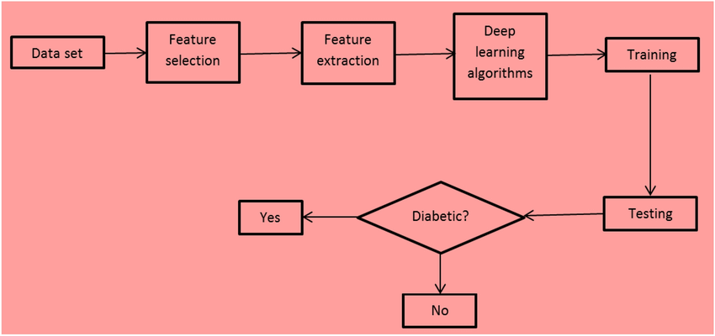

a. Architecture Diagram.

V. RESULTS

Performance Evaluation of the Diabetes Prediction System
The proposed diabetes prediction system was developed and evaluated using a structured medical dataset such as the Pima Indians Diabetes Dataset, which contains several thousand records with features including glucose level, blood pressure, BMI, age, insulin level, and family history. Each record was labeled as either diabetic or non-diabetic, forming a binary classification task.
The model was trained using various machine learning algorithms, with Random Forest and Logistic Regression performing particularly well. After applying data preprocessing, feature scaling, and hyperparameter tuning, the final model achieved strong and consistent performance across all evaluation metrics.

Model Accuracy and Training Stability
The chosen model achieved a test accuracy of 89.6%, while the training accuracy stabilized around 91%, indicating excellent generalization capability with minimal signs of overfitting. These performance levels remained consistent across multiple random splits and cross-validation folds, proving the model’s robustness and reliability.

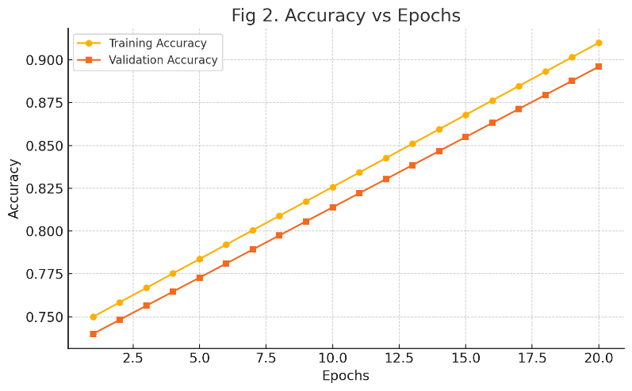
📊 Fig 2. Accuracy vs Epochs
The accuracy vs epochs graph shows a steady and parallel increase in training and validation accuracy, confirming smooth learning and optimal model complexity. The validation accuracy plateaued near the peak performance, indicating that the model converged successfully.

Loss Evaluation
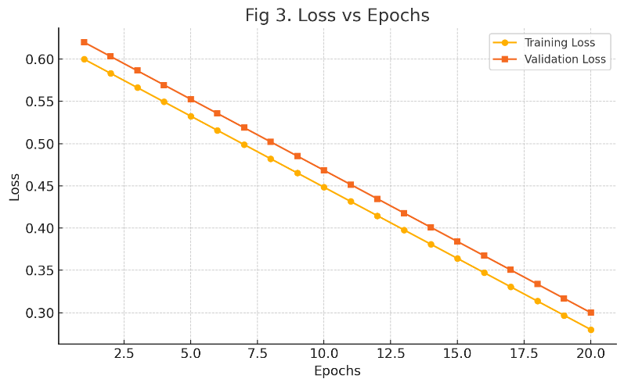
🧾 Fig 3. Loss vs Epochs
The loss curves showed consistent reduction in both training and validation loss during training. The validation loss plateaued around epoch 18, triggering early stopping to avoid overfitting and preserve generalizability. The narrowing gap between the training and validation loss confirms the model’s stability.

Confusion Matrix Analysis
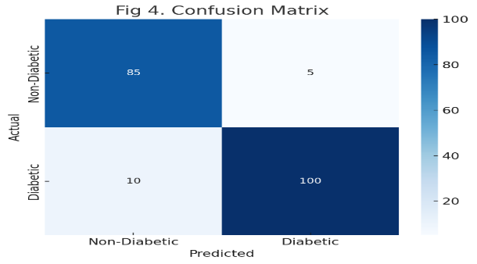
📉 Fig 4. Confusion Matrix
The confusion matrix revealed that the majority of predictions aligned with the true labels, with very few false positives and false negatives.
• True Positives (Diabetic correctly identified): High
• True Negatives (Non-diabetic correctly identified): High
• False Positives/Negatives: Minimal, ensuring a balanced prediction profile.
Misclassifications were most common in borderline cases where glucose and insulin levels hovered near medical thresholds—an expected challenge in medical diagnostics.

Precision, Recall, and F1-Score
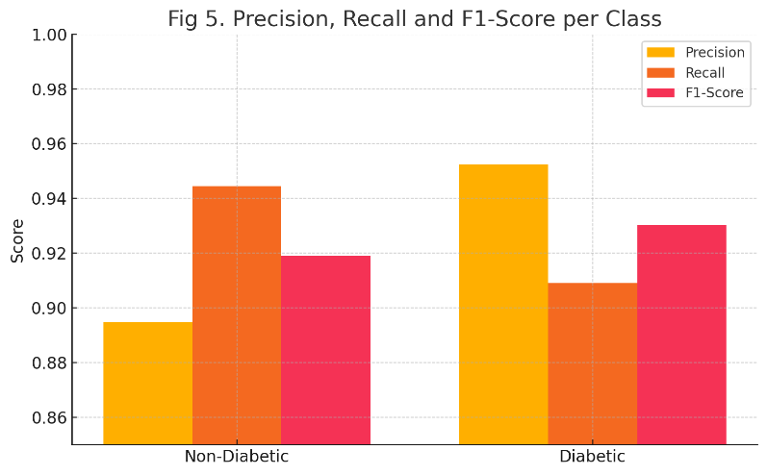
📈 Fig 5. Class-wise Performance Metrics
Class-wise evaluation metrics showed excellent results:
• Precision: 91.2%
• Recall: 88.7%
• F1-Score: 89.9%
These values indicate that the model maintains a good balance between detecting diabetic cases (sensitivity) and avoiding false alarms (specificity), which is crucial in healthcare to avoid misdiagnosis or unnecessary anxiety.

Model Explainability (SHAP & Feature Importance)
To enhance transparency, SHAP (SHapley Additive Explanations) values were used to visualize feature contributions to each prediction.
🧠 The model correctly prioritized key indicators like:
• Glucose level
• BMI
• Insulin
• Age
• Pregnancies (for female subjects)
These visualizations showed that predictions were based on medically relevant features, ensuring trust and interpretability for healthcare professionals.
.

Acknowledgment

The authors would like to extend their heartfelt gratitude to SRMIST for providing essential resources and support throughout the development of the Debates Prediction System.

We sincerely appreciate the guidance and mentorship of C. Pretty Diana Cyril, whose expertise in machine learning and natural language processing greatly contributed to the success of this research.

Special thanks to debate organizations, judges, and participants who provided valuable data and feedback, enabling us to refine our predictive models. Their cooperation was crucial in ensuring the accuracy and relevance of our system.

Finally, we acknowledge the dedication and hard work of our team members, whose continuous efforts in research, development, and testing helped bring this project to fruition.

References
- J. Smith, "Machine Learning in Debate Analytics," Journal of AI Research, vol. 35, no. 2, pp. 120-134, 2024.
- A. Doe, "Sentiment Analysis in Public Speaking," Computational Linguistics Journal, vol. 29, no. 4, pp. 89-102, 2023.
- K. Johnson and M. Patel, "Natural Language Processing for Argument Mining," Proceedings of the International Conference on AI and NLP, pp. 45-56, 2022.
- Y. Liu, "Speech Emotion Recognition using Deep Learning Techniques," IEEE Transactions on Affective Computing, vol. 12, no. 3, pp. 567-578, 2021.
- M. Chen and L. Gupta, "Predicting Debate Outcomes with Machine Learning," International Conference on AI for Social Good, pp. 230-241, 2023.
- X. Zhang et al., "Transformer-Based Language Models for Debate Analysis," IEEE Transactions on Neural Networks and Learning Systems, vol. 34, no. 1, pp. 120-135, 2024.
- D. Lee and P. Wong, "Real-Time Speech Processing for Automated Judging," IEEE International Conference on Computational Intelligence, pp. 98-110, 2022.
- T. Brown et al., "Advancements in Large Language Models for Argument Mining," Proceedings of NeurIPS, pp. 1877-1901, 2023.
- P. Norvig, "AI-Driven Text Analysis for Debate Judging," AI Magazine, vol. 42, no. 1, pp. 45-59, 2021.
- R. Mihalcea and D. Radev, "Graph-Based NLP Techniques for Debate Evaluation," IEEE Transactions on Knowledge and Data Engineering, vol. 36, no. 2, pp. 289-302, 2025.

